market economy:
- in a market economy provides surplus for state and makes cities rich
- A market economy is an economy in which the prices of goods and services are determined in a free price system.[1] This is often contrasted with a fixed price system.
self sufficient (domestic) agricultural societies:
feudal societies- started in Europe, tied to the land but lord paid tribute to them, able to make some profit, traded protection with lord for money
ladino - acculturated Africans often living in Portugal/Europe
bozales - non christian non romance language speakers Africans
baracoons: a place where slaves that were going to be traded were kept.
slave pens: a separate place from the master house where the slaves were kept. Barred up and hard to escape
chattel slavery: Such chattel slaves are used for their labor, sex, and breeding, and are exchanged for camels, trucks, guns, or money.
seasoning: period of forced adjustment to slavery before resale
indentured servants: An indentured servant was typically a young, unskilled laborer who came to America under contract to work for an employer for a fixed period of time, typically three to seven years, in exchange for their ocean transportation, food, clothing, lodging and other necessities during the term of their indenture
vassals: Vassal is a term used as part of feudalism in medieval Europe, where one enters into mutual obligations to a monarch, usually in the form of military support and mutual protection, in exchange for certain privileges, usually to include land held as a fiefdom. a person under the protection of a feudal lord to whom he has vowed homage and fealty : a feudal tenant
Atlantic Slave Trade (1500-1800): In the beginning, not based on race but towards the end it became about races.
- Triangle Trade

Europe

Middle East Africa

- Middle Passage
# of Africans landed alive- 10-12 million
where they landed-
- Brazil (40%)
- Carribean (40%)
- Peru, Chile, Argentina (10%)
- North America (10%)
where they came from
African Religions-
- what they believed: supreme creator, lesser deities (distinct powers, personalities), dance, eat, smoke, ancestors are linked to old life (guard culture and family)
- changes in African religions in Americas
African Burial Ground:
- in Mexico
Enslavement in Americas:
- differences/similarities:
- gender- women and men work together, but men do tougher work because women have children. US has fewer men because men were more expensive. Men were more successful in escaping because they had more knowledge of the area from going out with their owners
- plantation economy:
Maroons- communities comprised of newly arrived Africans, joined by fugitive slaves (creoles, whites, free people), created their own communities and drew others towards them (which in turn took away from plantation owners)

Garifuna - Instead of being forced to defend their territories from an encroaching colonial frontier, they found themselves transported around the Caribbean by various colonial powers for political and economic purposes. Spread among many countries, they have not constituted a unified political threat to established governments. But their proficiencies in the arts and crafts are widely celebrated, and they are currently the focus of efforts to increase tourism in the countries where they live. (maroon society)
Quilombo- maroon society in Brazil (large size)
Palmares- example of Quilombo
Mocambo- maroon society in Brazil (village size)

Africanisms: sense of being African in New World→ music, food, basket weaving, pottery, mining, world view of nationalities
Candonblé- African religion
Islam in the Diaspora- gendered towards women and children, Africans were minority in those enslaved, males slaves were often war captives who refused to convert but also captives who were purchased, soldiers, laborers, and eunuchs. Baghdad became a capital of muslim world and part of major slave revolt
Olaudah Equiano - was one of the most prominent Africans involved in the British movement towards the abolition of the slave trade
Zumbi: King Zumbi of Palmares (1605-1695)
Nanny- Queen Nanny of Jamaica
Culture of Resistance
types of resistance - overt and covert

MAP
Bight of Biafra
Bight of Benin
Gold Coast
Sierra Leone
Windward Coast
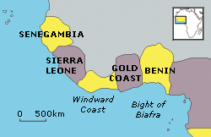
Kongo (Kingdom)
Congo River
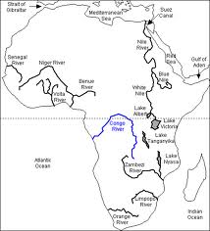
Sao Tome
The Canary Islands
Gulf of Guinea
Cape Verde Islands and town [2 different places]
Senegal River
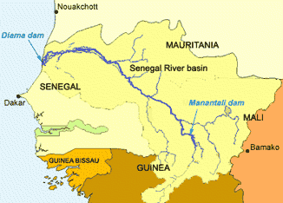
Gambia River
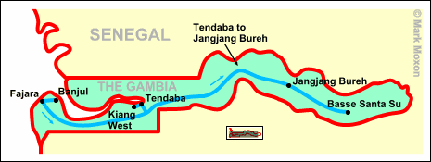
Niger River (Joliba)
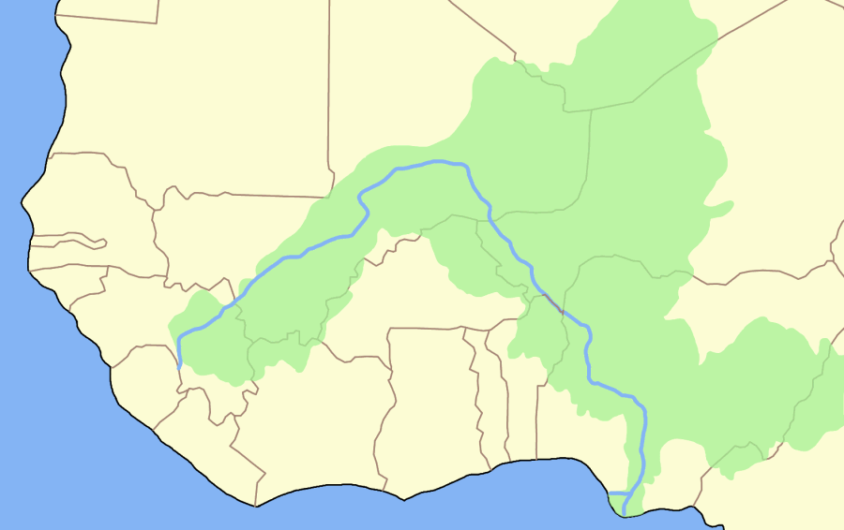
The Western Sudan
Angola, Luanda
Benin
Yoruba
Fon, Akan, Bambara, Igbo
Elmina
Cape Coast
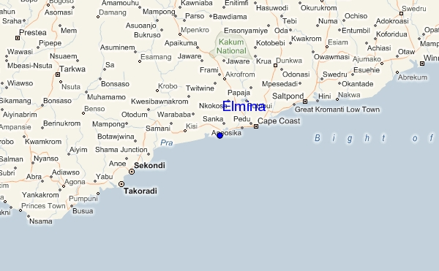
New Amsterdam
New York
Cartegena
Salvador
Bahia
Rio de Janeiro
Recife
Lima/Callao
Venezuela
Columbia
Guiana
Surinam
West Indies
- Hispanola
  - Haiti (Saint Domingue)
  - Dominican Republic
- Cuba
- Jamaica
- Puerto Rico
Mexico

SEGU @ refer to beginning of book for relationships
Mansa: title of Bambara emperor or king
Griot: historian musician singer flatterer, spy
Faro: god who oversaw smooth running of the universe night and day;
Pembe: creator of earth by whirling; pembele block of wood representing god
gris-gris: charms, amulets, potions
Segu: Kaarta; Timbuctoo; Jenne
Joliba: Niger river
Dousika Traore: male head figure
Was a yerewolo.
Dies which brings some sons back.
Nya: first (most important) wife of Dousika; A Kulibaly
Sira: concubine of Dousika who is pregnant with a child; Gives birth to Malobali and leaves Dousika aftera set amount of time and marries another man upon the return to her family (Amadou Tassirou)
Naba (Jean-Baptiste):
Captured as a slave.
Naba gets a new name Jean-Baptise.
Is a garderner to anne
Married Romona (Ayodele)
Goes to trial for something he didn’t commit.
Tiekoro (Oumar):
Eldest son who believes in the religion of Islam.
Tiekoro exiled to Timbuktu. Siga goes with him.
We find out that he is conceived on wedding night of Dousika and Nya
Tiekoro tries for ayisha and is rejected for his skin tone (daughter of Tiekoro’s host, El-Hadj Baba Abou)
Tiekoro rapes a bambara girl while at Timbuktu.
Tiekoro feels remorse the girl he raped and goes to see her and takes her as her own but doesnt completely know what that means.
Tiefolo son of DIemogo, Dousika's younger brother, sets out to Jenne to bring back tiekoro.
Nadie feels unneeded as Nya is taking care all the children now and all the servants do all the work.
She takes her youngest daughter and kills herself
Tiekoro goes to da monzon and tell him that he will travel to where Sira lives to tell her the bad news about her son dying.
Tiekoro offers Siga an opportunity to attempt to try his hand at a entrepreneurship job of trading and making items.
Siga (ahmed): Son of Dousika. His mother commited suicide by falling down into a well.
Siga is accepted as apprentice to a merchant while at Timbuktu.
Gets a merchantile job that gives him a little more power.
Siga gets told a girl by the name of Fatima loves him.
Goes with best friend to Fatima ‘s sister’s wedding.
Gets told their love must be asecret
Malobali (Samuel):
Son of Sira and Dousika
Malobali gets accused of rape by romona
Romona confesses to priest and tell malobali that he should marry her
He marries her but is still in love with his older brothers ex-wide Modupe
It seems Malobali and Romona are having a rough time producing children
Malobali has the ide to run away from Roman and go back to Segu where he can live and marry Modupe
Romona and her youngest son Eucaristus make it hard for him to leave.
Malobali goes to Abomey were he lies to be an ashanti and gets arrested for it.
Gets caught by reporting a false fact to Geuzo.
Romona goes to Abomey after hearing that Malobali has been imprisoned with Birame and Molara (his wife)
She gets her husband back, but Malobali falls ill with small pox from the “god” Sakpata who swears to be back for the king of Abomey
After Malobali’s death, Romona bears a child of his and dies.
Monzon Diarra:
Ruler in the beginning of the book
Biton Kulibaly:
founded the Bambara Empire. Used Segu as capital
Diarra’s took control of throne in the current book.
Samake:
Samake and Tietiguiba convince monzon to remove Dousika from his royal postion
Was the center of the plot against Dousika.
Treated like a conquered vassal by the Monzon

Koumare:
Fetish priest. Highest priest of the Komo
Belonged to one of the three great families of blacksmiths whose ancestors had discovered the secrets of metals
Misc. Segu notes:
Corvee - forced labor
Dolo – millet beer
N’gomi: millet fritters prepared by slaves
Pembele – a representation of the god Pembe
Boli – fetishes made of every kinds of materials
Hilakoro
Mori – muslim holy men
Yorba - farmers
Joliba – Bambara name for the Niger river
Tondyons - warlords
Scapegoats – Tiekoro, Siga, Naba and malobali
Fa – patriarch over five families
Komo – Influential secret society run by priests
Yerewolo- member of the royal council
Ardo – Fulani war chiefs, belonging to the diallo clan
Bilakoro – uncircumcised male child
Souka – mid-wife who delivers Dousika’s children
Moor - a member of a Muslim people of North Africa, of mixed Arab andBerber descent.
Wori - game resembling checkers
hakim – songhay for policeman
ara-koy – songhay for head donkey man
Gow – an ethinic group of hunters, holding sway over the uncultivated bush
Karamoko – Gow pupils
Diamou – patronymic
Foro – Bambara word for male sexual organ
Fama – Bambara for “my lord”
Signares – half-caste women in Goree
Dounoumba – the drum of rejoicing
But its daylight koke – tradition forbade lovemaking in daylight. It was punished by the birth of an albino child, thought to bea force of eveil
“Souroukou can tell a village that’s lived in from a village in ruins” - Proverb meaning “Everyone know what he is doing”
Celle – Songhay for half brother
Dyoro – camp leader
Moqaddem – religious teacher giving instructions to beginners
Kountas – Influential family of religious men and merchants, of arab origin, which produced a religious brotherhood known as the Kounti
Debiha – ceremony to provide protection
Nago – Synonomous with Yoruba, an ethnic group of present-day Nigeria
Koro – Bambara for elder bother
Bari – the mason’s guild in Jenne
Mossi – Ethinic group occupying present day Upper Volta
Garanke – Bambara leather workers
Chapadas – mountains whose peaks had been pounded flat
Iya – Yoruba for “mama”
Feitor - overseer
Komotigui – master of Komo high priest

